Embed tissue for sagittal sections
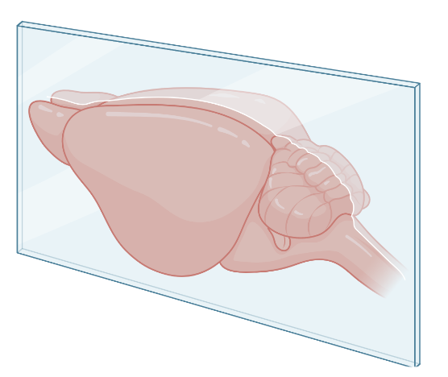
Material list
- Agarose
- TAE buffer 1X
- 50 ml tube lid
- Plastic pasteur pipet (3 ml)
- Scissors
- Microwave
- Erlenmeyer
- Tip (1000 µl)
- Blade
- Forceps

Protocol
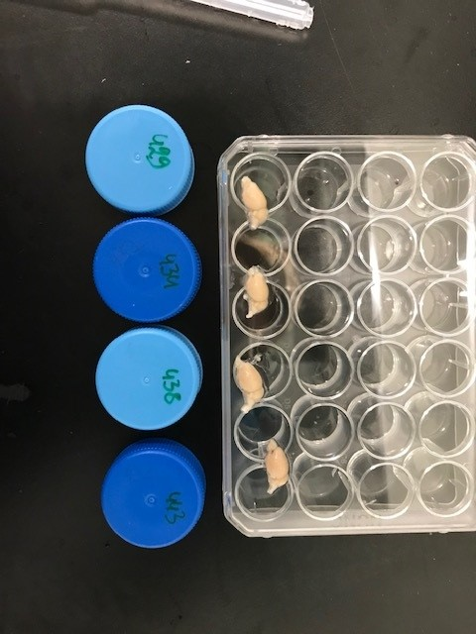
- Prepare a 5 % agarose solution in 1X TAE buffer. Weigh 5 g agarose and add 100 ml TAE in an Erlenmeyer. Heath it up very slowly (low wattage and only max 30 seconds per time with swirling in between). Make sure the agarose is dissolved in the TAE and leave it until most of the bubbles are gone.
- Cut the brain into 2 hemispheres with a blade and use the left side to imbed for sagittal sections. The right side can be put back in the PBS and stored in the fridge until further use.

- Take the 50 ml tube lid and fill the bottom with liquid 5 % agarose solution by using a 3 ml Pasteur pipet where the bottom, tinner part, is cut off. Check with the 1000 µl tip if the gel is between liquid and solid. If this is the case, put the left hemisphere on the gel with forceps. Check if it is straight and directly cover the full brain with 5 % agarose.

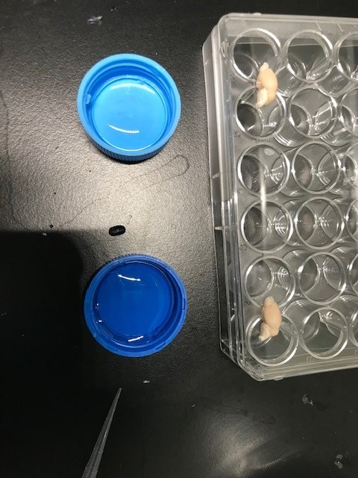
- Store the 50 ml tube lid with the imbedded brain in the fridge for further gelification and until further use.
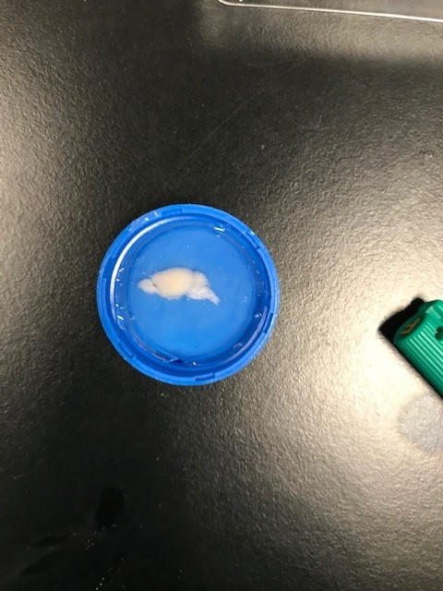

Sagittal sectioning using the vibratome
Material list
- Scalpel blade
- Imbedded brain
- Vibratome with its parts
  - cooling element
  - buffer tray
  - metal chuck = part to attach the brain
  - chuck fork = to put the metal chuck in the buffer tray via a magnetic system
  - hexagon head wrench to fasten the blade
- Blade
- Cold PBS (4 °C)
- Instant glue
- Curved tip forceps
- 24 well plate
- 0.1 % sodium azide
- Syringe (± 20 ml)
- Tray
- Paint brush
Protocol
- Cut the imbedded brain out of the 50 ml tube lid with a scalpel blade (see figure).
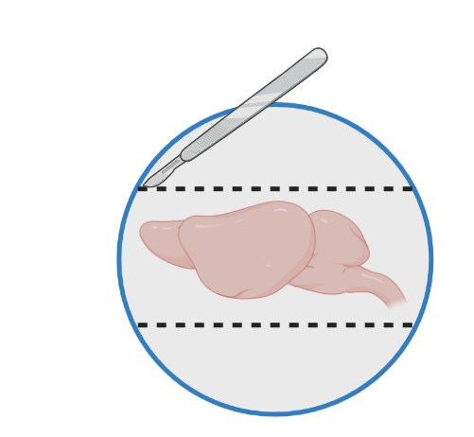
- Paste the imbedded brain to the metal chuck with instant glue.
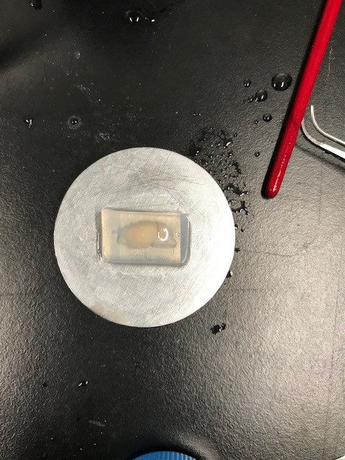
- During the drying process of the glue, two 24 well plates can be filled with 0.1 % sodium azide and labeled:
  - Mouse ID
  - Genotype
  - Treatment
  - Age
  - Current date
  - Researchers initials
  - Plate 1 or 2
The plates are also labeled at the side with a vertical line to know which lid belongs to which bottom.
- Put the cooling element correctly positioned in the buffer tank.
- Take a blade and fasten it on the vibratome using the hexagon head wrench.
- Put the metal chuck with the glued brain at its position using the chuck fork.
- Fill the buffer tank with PBS stored at 4 °C until the whole imbedded brain is under PBS.
- Set the window of the vibratome by pushing the window button: 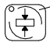. Window 1 is the starting position of the blade and window 2 the end position. Use the arrows to put the blade in the correct position and the window button to switch between window 1 and 2.
- The feed is the thickness of the sections and should be set on 40 (µm) using the upper screw at the side of the vibratome.
- For speed you can start at 18 when it is the first time and it can be increased to 25. Speed is adapted using the lower screw at the side of the vibratome.
- When the vibratome is put on single mode, it will only cut one section per time. If it is put on continues mode, the vibratome will keep cutting until you press stop.
- By pressing start the vibratome will start cutting the sections. The sections are collected one after the other with a brush in a different well in the 24 well plate. When there is a section in each well you will continue in well 1A of plate 1 again.
- If the PBS level becomes to high during cutting, you can lower the level by removing PBS into the tray using the syringe.
- When you are finished you press stop, take out the metal chuck with the chuck fork, remove the left over gel and tissue with the blade, discard the PBS in the sink and clean everything with AD.
- The sections can be stored at 4 °C until further use.

